CALL

MAIN MATRIX
S₀ = 100 | Time = 1 | Sigma = 0.02 | Lamda = 1.22474 | Risk free = 0.05
Number of iterations | CRR | KR | DiffCRR | DiffKR
 |  | K = 90 | BS = 16.6994
5 | 16.5590 | 16.6374 | 0.1404 | 0.0621
10 | 16.7222 | 16.7419 | -0.0227 | -0.0425
20 | 16.7006 | 16.6901 | -0.0012 | 0.0093
40 | 16.7252 | 16.7081 | -0.0258 | -0.0086
60 | 16.6818 | 16.7061 | 0.1760 | -0.0066
80 | 16.7119 | 16.7000 | -0.0125 | -0.0006
100 | 16.7105 | 16.7030 | -0.0110 | -0.0035
 |  | K = 100 | BS = 10.4506
5 | 10.8059 | 10.3320 | -0.3554 | 0.1185
10 | 10.2534 | 10.3887 | 0.1972 | 0.0618
20 | 10.3513 | 10.4192 | 0.0993 | 0.0314
40 | 10.4008 | 10.4348 | 0.0498 | 0.0158
60 | 10.4173 | 10.4400 | 0.0333 | 0.0106
80 | 10.4256 | 10.4427 | 0.0250 | 0.0079
100 | 10.4306 | 10.4442 | 0.0200 | 0.0064
 |  | K = 110 | BS = 6.0401
5 | 5.6518 | 6.0020 | 0.3883 | 0.0380
10 | 6.0992 | 6.0562 | -0.0591 | -0.0161
20 | 5.9662 | 6.0537 | 0.0739 | -0.0136
40 | 6.0789 | 6.0549 | -0.0388 | -0.0148
60 | 6.0347 | 6.0267 | 0.0054 | 0.0133
80 | 6.0322 | 6.0476 | 0.0079 | -0.0075
100 | 6.0532 | 6.0371 | -0.0131 | 0.0030

PLOTS (DIFFERENT LAMDA)

AT THE MONEY

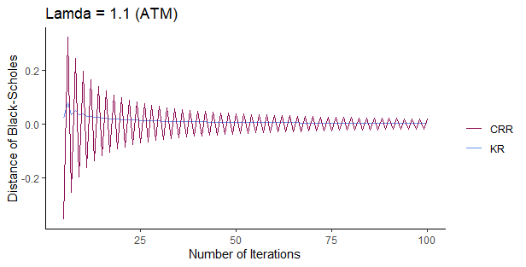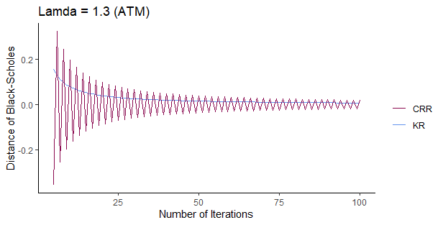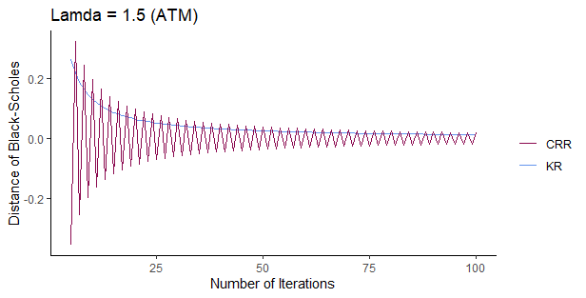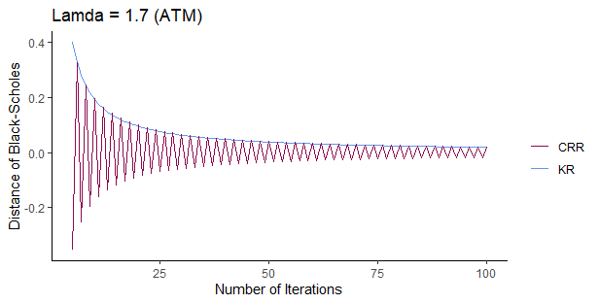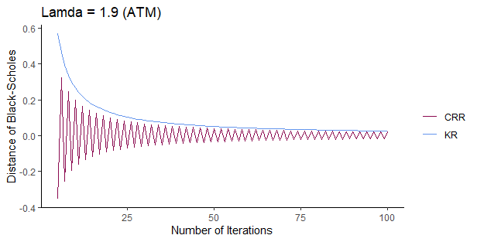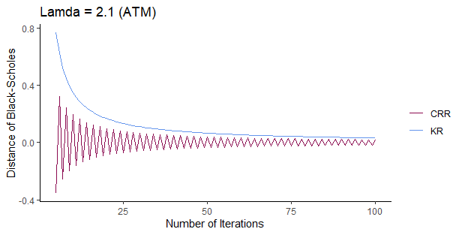

IN THE MONEY

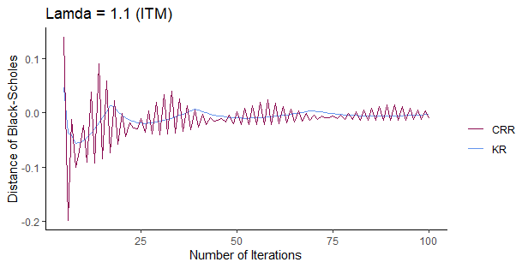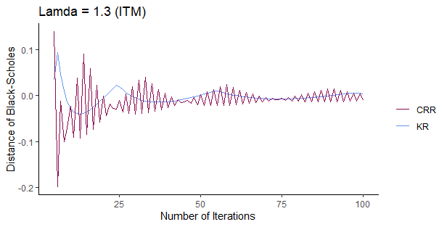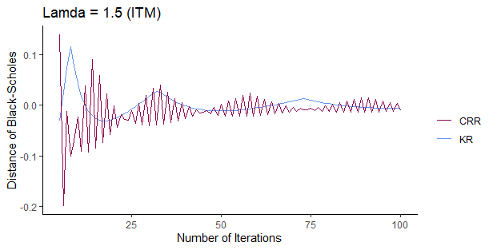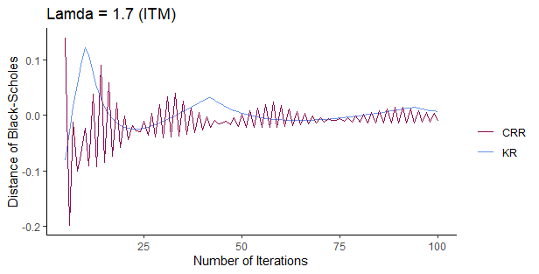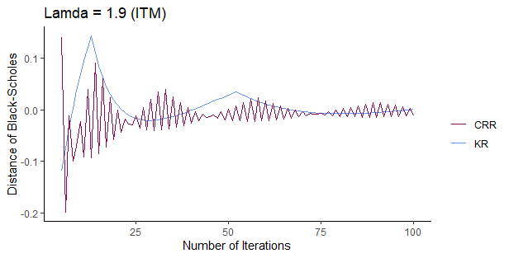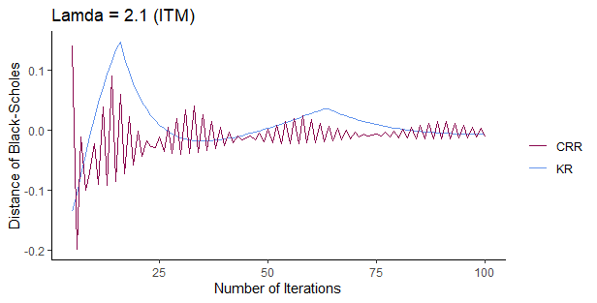

OUT THE MONEY

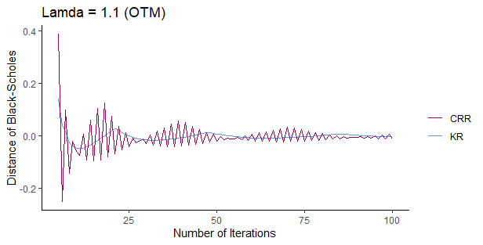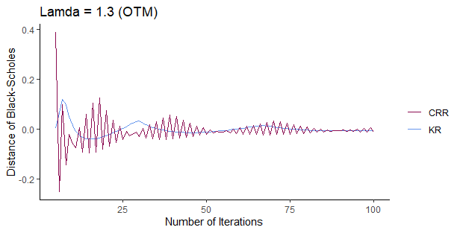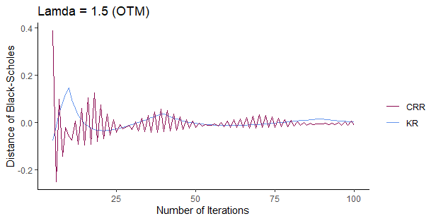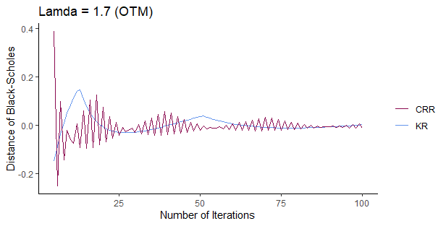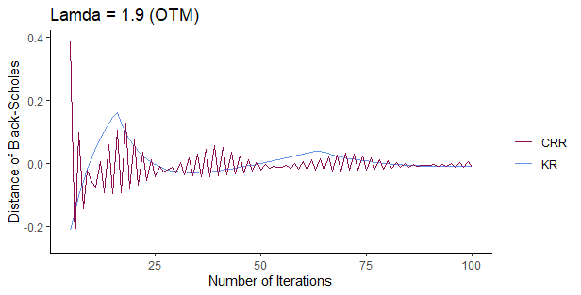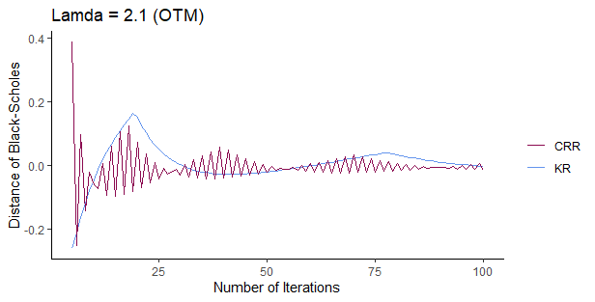

VOLATILITY ANALYSIS
S₀ = 100 | K = 100 | Risk Free = 0.05 | Lamda = 1.22474 | Time = 1
Number of iterations | CRR | KR | DiffCRR | DiffKR
 |  | Sigma = 0.15 | BS = 8.5917
5 | 8.8380 | 8.4831 | -0.2464 | 0.1086
10 | 8.4406 | 8.5356 | 0.1510 | 0.0560
20 | 8.5156 | 8.5633 | 0.0761 | 0.0283
40 | 8.5535 | 8.5774 | 0.0382 | 0.0142
60 | 8.5662 | 8.5821 | 0.0255 | 0.0095
80 | 8.5725 | 8.5845 | 0.0191 | 0.0071
100 | 8.5764 | 8.5859 | 0.0153 | 0.0057
 |  | Sigma = 0.18 | BS = 9.7023
5 | 10.0149 | 9.5884 | -0.3126 | 0.1139
10 | 9.5237 | 9.6431 | 0.1786 | 0.0592
20 | 9.6123 | 9.6723 | 0.0900 | 0.0300
40 | 9.6572 | 9.6872 | 0.0452 | 0.0151
60 | 9.6722 | 9.6922 | 0.0301 | 0.0101
80 | 9.6797 | 9.6948 | 0.0226 | 0.0076
100 | 9.6842 | 9.6963 | 0.0181 | 0.0061
 |  | Sigma = 0.24 | BS = 11.9578
5 | 12.3961 | 11.8279 | -0.4383 | 0.1299
10 | 11.7234 | 11.8897 | 0.2344 | 0.0681
20 | 11.8397 | 11.9231 | 0.1181 | 0.0346
40 | 11.8985 | 11.9403 | 0.0592 | 0.0175
60 | 11.9182 | 11.9461 | 0.0395 | 0.0117
80 | 11.9281 | 11.9490 | 0.0297 | 0.0088
100 | 11.9340 | 11.9508 | 0.0237 | 0.0070

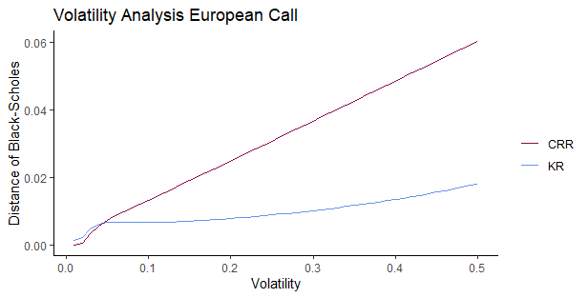

RISK FREE ANALYSIS
S₀ = 100 | K = 100 | Sigma = 0.02 | Lamda = 1.22474 | Time = 1
Number of iterations | CRR | KR | DiffCRR | DiffKR
 |  | Risk free = 0.01 | BS = 8.4333
5 | 8.8327 | 8.3416 | -0.3994 | 0.0917
10 | 8.2377 | 8.3847 | 0.1956 | 0.0487
20 | 8.3348 | 8.4085 | 0.0985 | 0.0248
40 | 8.3839 | 8.4208 | 0.0494 | 0.0125
60 | 8.4003 | 8.4249 | 0.0330 | 0.0084
80 | 8.4086 | 8.4270 | 0.0248 | 0.0063
100 | 8.4135 | 8.4283 | 0.0198 | 0.0050
 |  | Risk free = 0.04 | BS = 9.9251
5 | 10.2956 | 9.8184 | -0.3706 | 0.1066
10 | 9.7289 | 9.8691 | 0.1962 | 0.056
20 | 9.8262 | 9.8966 | 0.0988 | 0.0285
40 | 9.8755 | 9.9107 | 0.0496 | 0.0144
60 | 9.8920 | 9.9155 | 0.0331 | 0.0096
80 | 9.9002 | 9.9178 | 0.0248 | 0.0072
100 | 9.9052 | 9.9193 | 0.0199 | 0.0058
 |  | Risk free = 0.07 | BS = 11.5415
5 | 11.8590 | 11.3891 | -0.3175 | 0.1524
10 | 11.3414 | 11.4630 | 0.2001 | 0.0785
20 | 11.4407 | 11.5018 | 0.1008 | 0.0397
40 | 11.4909 | 11.5215 | 0.0506 | 0.0199
60 | 11.5077 | 11.5282 | 0.0338 | 0.0133
80 | 11.5161 | 11.5315 | 0.0253 | 0.0100
100 | 11.5212 | 11.5335 | 0.0203 | 0.0080

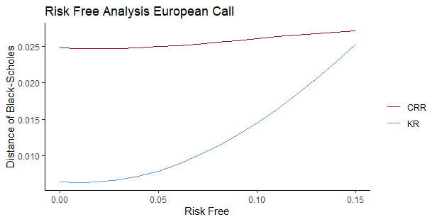

TIME ANALYSIS
S₀ = 100 | K = 100 | Sigma = 0.02 | Lamda = 1.22474 | Risk free = 0.05
Number of iterations | CRR | KR | DiffCRR | DiffKR
 |  | Time = 2/12 | BS = 3.6747
5 | 3.8370 | 3.6365 | -0.1623 | 0.0382
10 | 3.5944 | 3.6545 | 0.0804 | 0.0203
20 | 3.6343 | 3.6644 | 0.0405 | 0.0103
40 | 3.6544 | 3.6695 | 0.0203 | 0.0052
60 | 3.6612 | 3.6712 | 0.0136 | 0.0035
80 | 3.6646 | 3.6721 | 0.0102 | 0.0026
100 | 3.6666 | 3.6726 | 0.0081 | 0.0021
 |  | Time = 5/12 | BS = 6.1907
5 | 6.4389 | 6.1259 | -0.2482 | 0.0648
10 | 6.0635 | 6.1565 | 0.1272 | 0.0341
20 | 6.1266 | 6.1733 | 0.0641 | 0.0174
40 | 6.1585 | 6.1819 | 0.0321 | 0.0088
60 | 6.1692 | 6.1848 | 0.0214 | 0.0059
80 | 6.1746 | 6.1863 | 0.0161 | 0.0044
100 | 6.1778 | 6.1871 | 0.0129 | 0.0035
 |  | Time = 8/12 | BS = 8.1726
5 | 8.4762 | 8.0846 | -0.3036 | 0.0880
10 | 8.0116 | 8.1264 | 0.1609 | 0.0462
20 | 8.0915 | 8.1491 | 0.0811 | 0.0235
40 | 8.1319 | 8.1607 | 0.0407 | 0.0118
60 | 8.1454 | 8.1647 | 0.0271 | 0.0079
80 | 8.1522 | 8.1666 | 0.0204 | 0.0059
100 | 8.1563 | 8.1678 | 0.0163 | 0.0048

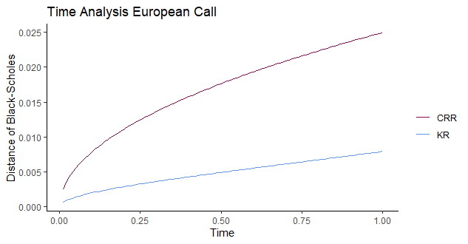

EUROPEAN PUT

MAIN MATRIX
S₀ = 100 | Time = 1 | Sigma = 0.02 | Lamda = 1.22474 | Risk free = 0.05
Number of iterations | CRR | KR | DiffCRR | DiffKR
 |  | K = 90 | BS = 2.3101
5 | 2.1697 | 2.2649 | 0.1404 | 0.0452
10 | 2.3328 | 2.3610 | -0.0227 | -0.0509
20 | 2.3113 | 2.3050 | -0.0012 | 0.0051
40 | 2.3359 | 2.3208 | -0.0258 | -0.0107
60 | 2.2925 | 2.3181 | 0.0176 | -0.0080
80 | 2.3226 | 2.3117 | -0.0125 | -0.0016
100 | 2.3211 | 2.3145 | -0.0110 | -0.0044
 |  | K = 100 | BS = 5.5735
5 | 5.9289 | 5.4719 | -0.3554 | 0.1016
10 | 5.3764 | 5.5202 | 0.1972 | 0.0534
20 | 5.4742 | 5.5464 | 0.0993 | 0.0271
40 | 5.5237 | 5.5598 | 0.0498 | 0.0137
60 | 5.5403 | 5.5644 | 0.0333 | 0.0091
80 | 5.5486 | 5.5667 | 0.0250 | 0.0069
100 | 5.5536 | 5.5680 | 0.0200 | 0.0055
 |  | K = 110 | BS = 10.6753
5 | 10.2871 | 10.6542 | 0.3883 | 0.0211
10 | 10.7344 | 10.6999 | -0.0591 | -0.0245
20 | 10.6015 | 10.6932 | 0.0739 | -0.0178
40 | 10.7141 | 10.6923 | -0.0388 | -0.0169
60 | 10.6699 | 10.6634 | 0.0054 | 0.0119
80 | 10.6674 | 10.6839 | 0.0079 | -0.0085
100 | 10.6885 | 10.6732 | -0.0131 | 0.0022

PLOTS (DIFFERENT LAMDA)

AT THE MONEY
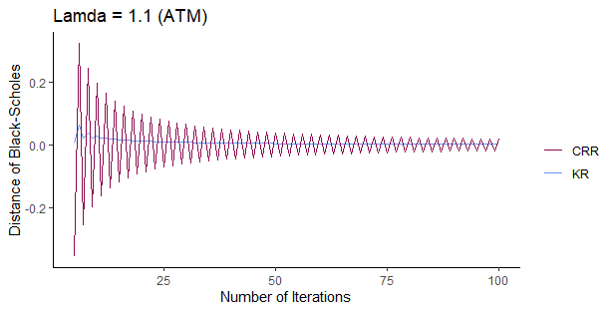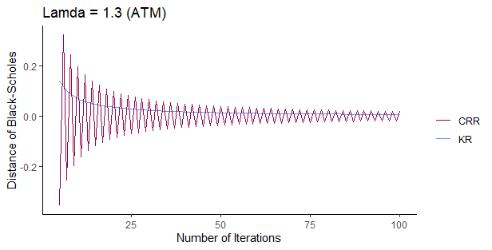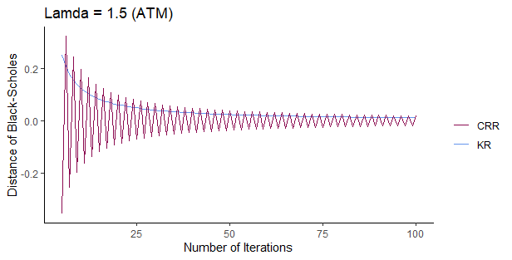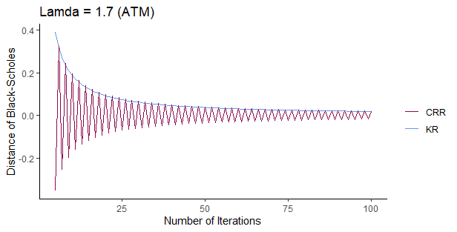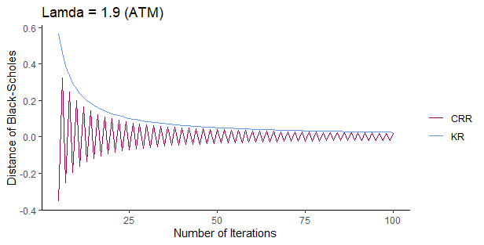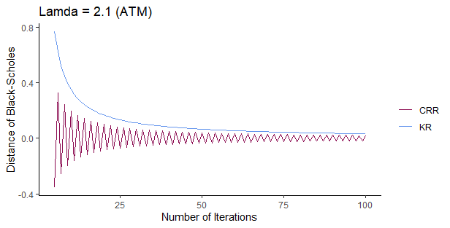

IN THE MONEY
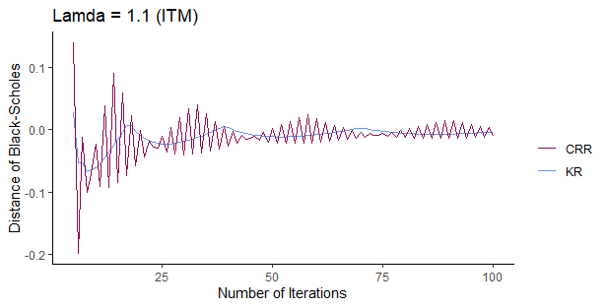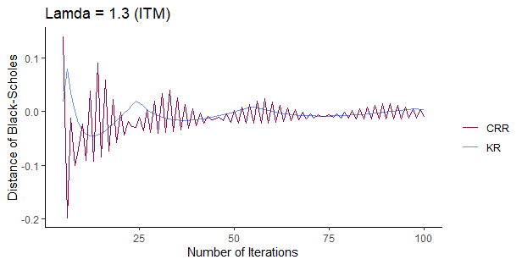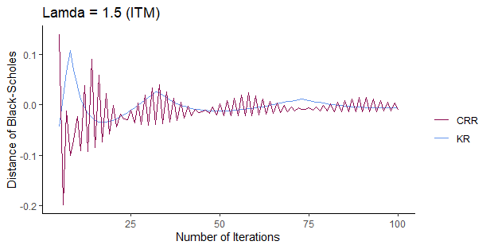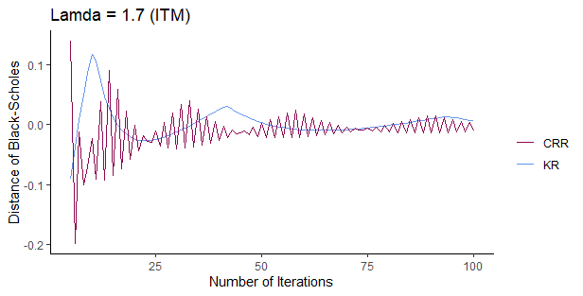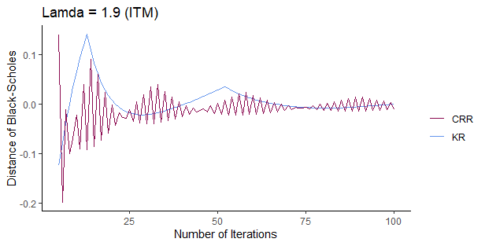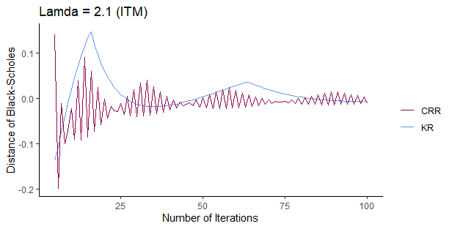

OUT THE MONEY

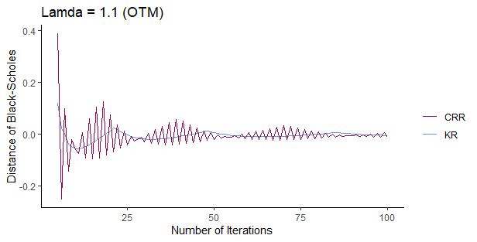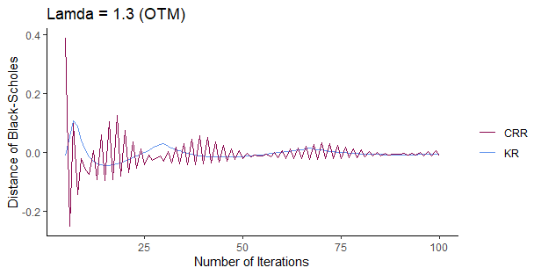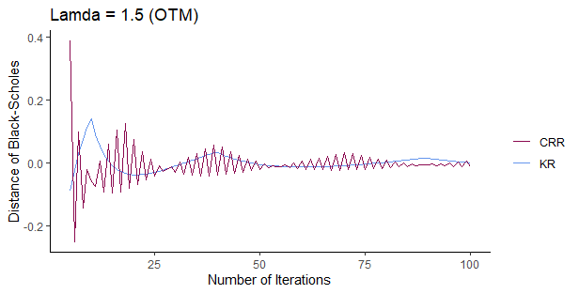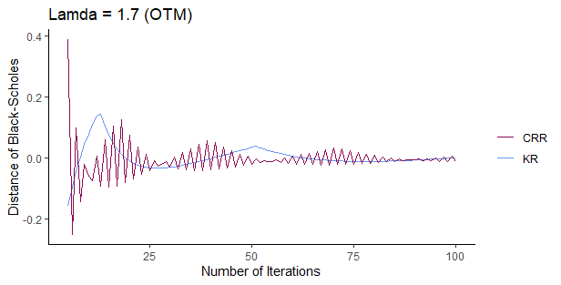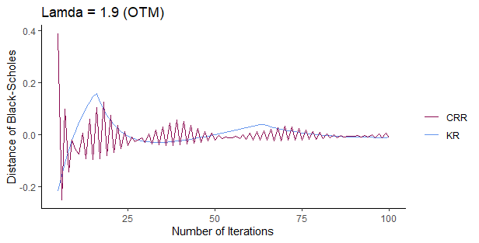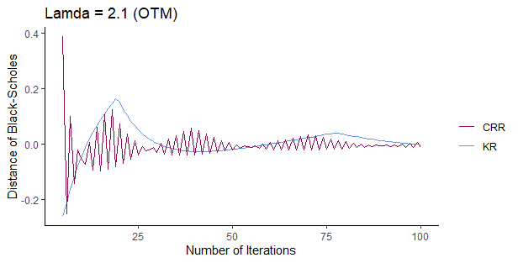

VOLATILITY ANALYSIS

S₀ = 100 | K = 100 | Risk Free = 0.05 | Lamda = 1.22474 | Time = 1
Number of iterations | CRR | KR | DiffCRR | DiffKR
 |  | Sigma = 0.15 | BS = 3.7146
5 | 3.9610 | 3.6259 | -0.2464 | 0.0887
10 | 3.5636 | 3.6686 | 0.1510 | 0.0460
20 | 3.6385 | 3.6913 | 0.0761 | 0.0233
40 | 3.6764 | 3.7029 | 0.0382 | 0.0117
60 | 3.6891 | 3.7068 | 0.0255 | 0.0078
80 | 3.6955 | 3.7087 | 0.0191 | 0.0059
100 | 3.6993 | 3.7099 | 0.0153 | 0.0047
 |  | Sigma = 0.18 | BS = 4.8253
5 | 5.1379 | 4.7295 | -0.3126 | 0.0958
10 | 4.6466 | 4.7752 | 0.1786 | 0.0501
20 | 4.7353 | 4.7998 | 0.0900 | 0.0255
40 | 4.7801 | 4.8125 | 0.0452 | 0.0128
60 | 4.7952 | 4.8167 | 0.0301 | 0.0086
80 | 4.8027 | 4.8188 | 0.0226 | 0.0064
100 | 4.8072 | 4.8201 | 0.0181 | 0.0052
 |  | Sigma = 0.24 | BS = 7.0807
5 | 7.5191 | 6.9655 | -0.4383 | 0.1152
10 | 6.8463 | 7.0200 | 0.2344 | 0.0608
20 | 6.9626 | 7.0498 | 0.1181 | 0.0310
40 | 7.0215 | 7.0651 | 0.0592 | 0.0156
60 | 7.0412 | 7.0703 | 0.0395 | 0.0104
80 | 7.0511 | 7.0729 | 0.0297 | 0.0078
100 | 7.0570 | 7.0744 | 0.0237 | 0.0063

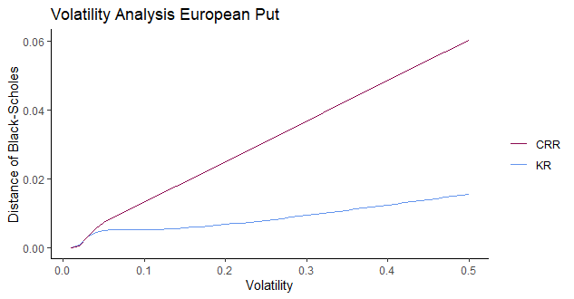

RISK FREE ANALYSIS
S₀ = 100 | K = 100 | Sigma = 0.02 | Lamda = 1.22474 | Time = 1
Number of iterations | CRR | KR | DiffCRR | DiffKR
 |  | Risk free = 0.01 | BS = 7.4383
5 | 7.8377 | 7.3476 | -0.3994 | 0.0907
10 | 7.2427 | 7.3901 | 0.1956 | 0.0482
20 | 7.3398 | 7.4137 | 0.0985 | 0.0246
40 | 7.3889 | 7.4259 | 0.0494 | 0.0124
60 | 7.4053 | 7.4300 | 0.0330 | 0.0083
80 | 7.4135 | 7.4321 | 0.0248 | 0.0062
100 | 7.4185 | 7.4333 | 0.0198 | 0.0050
 |  | Risk free = 0.04 | BS = 6.0040
5 | 6.3746 | 5.9073 | -0.3706 | 0.0967
10 | 5.8078 | 5.9530 | 0.1962 | 0.0510
20 | 5.9052 | 5.9780 | 0.0988 | 0.0260
40 | 5.9544 | 5.9909 | 0.0496 | 0.0131
60 | 5.9709 | 5.9952 | 0.0331 | 0.0088
80 | 5.9792 | 5.9974 | 0.0248 | 0.0066
100 | 5.9841 | 5.9987 | 0.0199 | 0.0053
 |  | Risk free = 0.07 | BS = 4.7809
5 | 5.0984 | 4.6651 | -0.3175 | 0.1157
10 | 4.5807 | 4.7208 | 0.2001 | 0.0601
20 | 4.6801 | 4.7504 | 0.1008 | 0.0304
40 | 4.7303 | 4.7655 | 0.0506 | 0.0153
60 | 4.7471 | 4.7706 | 0.0338 | 0.0102
80 | 4.7555 | 4.7732 | 0.0253 | 0.0077
100 | 4.7606 | 4.7747 | 0.0203 | 0.0062

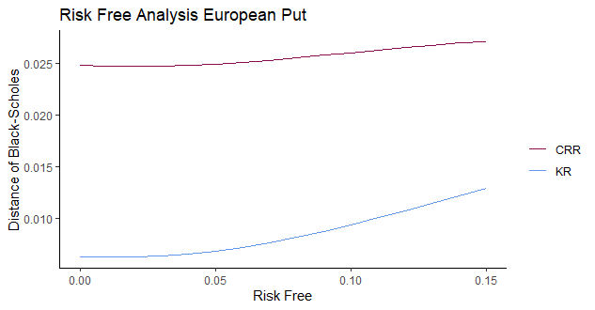

TIME ANALYSIS
S₀ = 100 | K = 100 | Sigma = 0.02 | Lamda = 1.22474 | Risk free = 0.05
Number of iterations | CRR | KR | DiffCRR | DiffKR
 |  | Time = 2/12 | BS = 2.8449
5 | 3.0072 | 2.8071 | -0.1623 | 0.0378
10 | 2.7645 | 2.8248 | 0.0804 | 0.0200
20 | 2.8044 | 2.8346 | 0.0405 | 0.0102
40 | 2.8246 | 2.8397 | 0.0203 | 0.0052
60 | 2.8313 | 2.8414 | 0.0136 | 0.0035
80 | 2.8347 | 2.8423 | 0.0102 | 0.0026
100 | 2.8367 | 2.8428 | 0.0081 | 0.0021
 |  | Time = 5/12 | BS = 4.1289
5 | 4.3771 | 4.0671 | -0.2482 | 0.0618
10 | 4.0017 | 4.0962 | 0.1272 | 0.0327
20 | 4.0648 | 4.1122 | 0.0641 | 0.0167
40 | 4.0968 | 4.1205 | 0.0321 | 0.0084
60 | 4.1074 | 4.1233 | 0.0214 | 0.0056
80 | 4.1128 | 4.1247 | 0.0161 | 0.0042
100 | 4.1160 | 4.1255 | 0.0129 | 0.0034
 |  | Time = 8/12 | BS = 4.8942
5 | 5.1978 | 4.8137 | -0.3036 | 0.0804
10 | 4.7333 | 4.8518 | 0.1609 | 0.0424
20 | 4.8131 | 4.8726 | 0.0811 | 0.0216
40 | 4.8535 | 4.8833 | 0.0407 | 0.0109
60 | 4.8670 | 4.8869 | 0.0271 | 0.0073
80 | 4.8738 | 4.8887 | 0.0204 | 0.0055
100 | 4.8779 | 4.8898 | 0.0163 | 0.0044

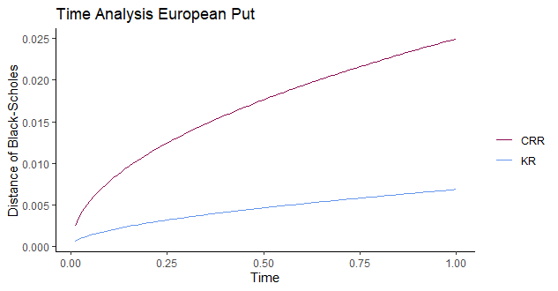

CRR EVEN-ODD STEPS
AT THE MONEY

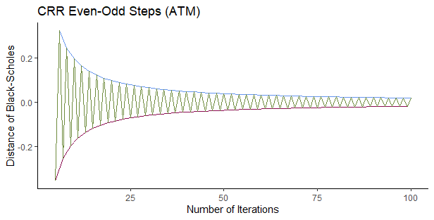

KR PROBABILITY ANALYSIS

 | 1 | 1.1 | 1.22474 | 1.4 | 1.7 | 1.9 | 2.1
Prob.1 | 0.50839 | 0.42085 | 0.34018 | 0.26109 | 0.17794 | 0.14292 | 0.11737
Prob.3 | 0.49161 | 0.40560 | 0.32648 | 0.24911 | 0.16808 | 0.13409 | 0.10939
Prob.2 | 0.00000 | 0.17355 | 0.33332 | 0.48980 | 0.65398 | 0.72299 | 0.77324

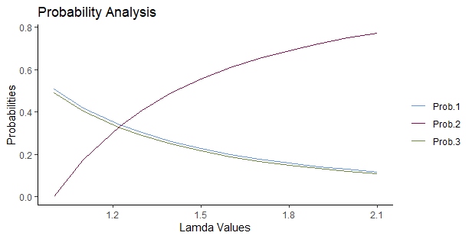

KR PUT-CALL PARITY CONVERGENCE

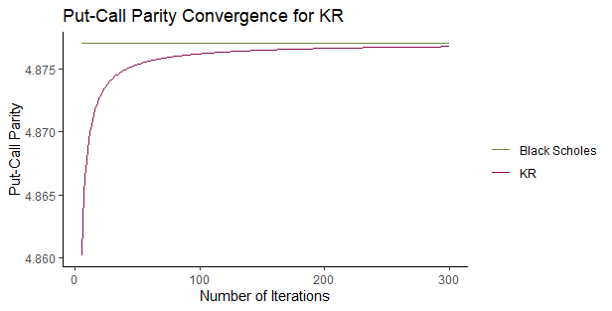

MINIMUM CONVERGENCE STEP FOR KR AND CRR

CALL

 | Call Option
So = 100 | Volatility = 0.2 | Time = 1 , Risk Free = 0.05
Strike  Price | CRR | KR
 | Precision level: 0.5%
90 | 16 | 4
100 | 39 | 12
110 | 71 | 18
Average | 42.0 | 11.3
 | Precision level: 1%
90 | 7 | 3
100 | 19 | 6
110 | 22 | 8
Average | 16.0 | 5.6
 | Precision level: 5%
90 | 2 | 1
100 | 4 | 1
110 | 6 | 3
Average | 4.0 | 1.6

EUROPEAN PUT
 | Put Option
So = 100 | Volatility = 0.2 | Time = 1 , Risk Free = 0.05
Strike  Price | CRR | KR
 | Precision level: 0.5%
90 | 99 | 40
100 | 71 | 20
110 | 40 | 8
Average | 70.0 | 22.6
 | Precision level: 1%
90 | 59 | 17
100 | 35 | 10
110 | 19 | 4
Average | 37.6 | 10.3
 | Precision level: 5%
90 | 7 | 4
100 | 7 | 3
110 | 3 | 2
Average | 5.6 | 3.0

AMERICAN PUT
Volatility = 0.2 | American Put  Option | Time = 1 , Risk Free = 0.05
Strike  Price | CRR | KR
 | Precision level: 0.5%
90 | 70 | 36
100 | 46 | 13
110 | 16 | 4
Average | 44.0 | 17.6
 | Precision level: 1%
90 | 41 | 15
100 | 22 | 6
110 | 5 | 3
Average | 22.6 | 8
 | Precision level: 5%
90 | 7 | 3
100 | 4 | 2
110 | 2 | 1
Average | 4.3 | 2.0

Root Mean Squared Error

Call Option

Periods | RMSE_CRR | RMSE_KR
25 | 0.00550768 | 0.00257283
50 | 0.00275219 | 0.00128164
100 | 0.00139804 | 0.00064203
200 | 0.00068955 | 0.00031174
400 | 0.00034254 | 0.00015898
800 | 0.00017079 | 0.00008018

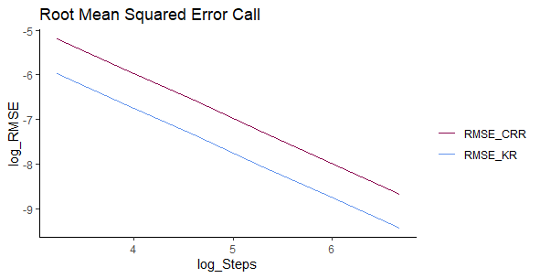

European Put Option

Periods | RMSE_CRR | RMSE_KR
25 | 0.00848605 | 0.00413394
50 | 0.00438803 | 0.00196155
100 | 0.00215207 | 0.00097302
200 | 0.00106449 | 0.00049077
400 | 0.00053358 | 0.00025048
800 | 0.00026361 | 0.00012548

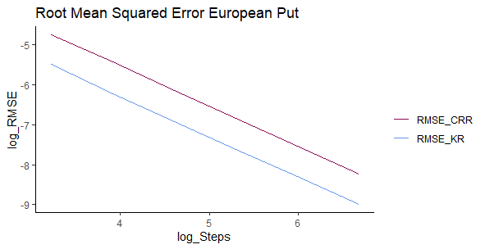

American Put Option

Periods | RMSE_CRR | RMSE_KR
25 | 0.00690142 | 0.00343888
50 | 0.00348670 | 0.00166291
100 | 0.00172567 | 0.00079874
200 | 0.00081608 | 0.00037697
400 | 0.00039078 | 0.00016888
800 | 0.00018873 | 0.00008021

